26.70: a) With an open switch: 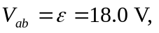 since equilibrium has been reached.
b) Point “a” is at a higher potential since it is directly connected to the positive terminal of the battery.

c) When the switch is closed:
d) Initially the capacitor’s charges were:
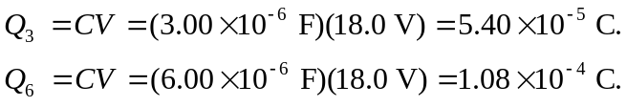
After the switch is closed:
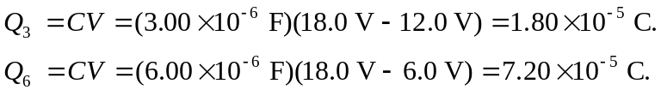
So both capacitors lose 